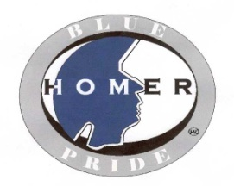
Homer Central School District
Course: College & Career Ready
Topic: Study & Exam Skills |  |  | Time: 2-3 Weeks
Essential Questions:
- How do I learn best?
- What can I do to best prepare myself for testing/exams?
- When doing research how do I decipher good information from bad information on the internet?

Key Vocabulary:
Guiding Questions | Essential Knowledge & Skills (Know and be able to do) | Performance Indicators |  | Learning Opportunities  (Instructional Strategies) | Assessment Ideas  (Evidence of Understanding)
- What are different styles of learning?  - What can I do for myself to help ensure learning?  - What is the most beneficial note taking strategy for me?  - What is the best strategy for me to prepare for an exam?  - What are some good test taking strategies?  - How do I know if a website is credible or not?  - How do I navigate a website to find the information I need? | - Identify how you learn best  - List and explain basic lecture and note-taking techniques  - Employ note-taking techniques that best suit your learning strategy  - List and explain basic exam-prep and exam-taking strategies  - Employ exam-prep and taking strategies that best fit your learning style  - Conduct research on the internet using only credible websites | - CDOS 1, 2, 3a & 3b  - NBEA.CD.I, V & VI  - NBEA.CM.I & II  - CCR.SL.11-12.1 & 6  - CCR.L.11-12.1 & 2  - CCR.RI.11-12.10  - CCR.W.11-12.4, 6 & 10 |  | - Presentations  - Class/group discussions  - Blog/online discussion  - Worksheets  - Professional guest speakers  - Videos | - Exam Prep  - Demonstrate how you learn best simulation  - Article summaries  - Professionalism  - Portfolio due at end of semester
Resources:
Connections to Technology: Use of computers (reading online blogs & articles, creating documents in Office software, online research and videos)

